**FOR IMMEDIATE RELEASE**

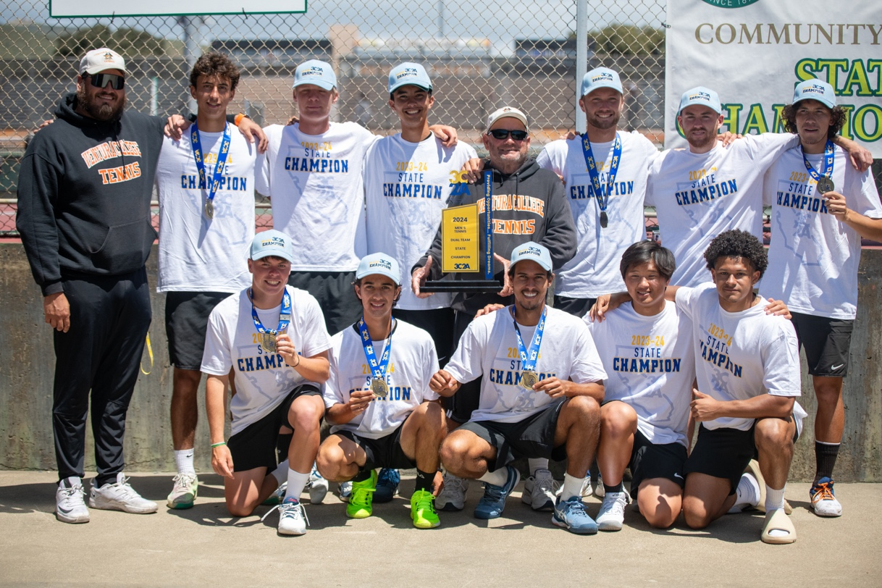

Ventura College Men's Tennis Team celebrating their State Championship Win

**Ventura College Men's Tennis Team Clinches 3C2A State Championship in Stunning Victory**

**Ventura, Calif.** (May 6, 2024) — Ventura College men's tennis team concluded their 2024 season in triumphant fashion, securing a 5-0 victory over American River College from Sacramento in the 3C2A State Championship. This victory marks the third state title for Ventura College under the leadership of longtime head coach Nelson Emery, their first since 2010.

The championship match showcased the team's exceptional talent and determination. In doubles play, the Pirates displayed remarkable resilience. Despite facing tough competition, Ventura's duos delivered outstanding performances. Rafael Matias and Julian Tellez rallied to win three consecutive games, clinching the first point of the championship with an 8-5 victory. Robinson Pelluault and Edgar Ploquin also shone, winning their contest 8-3 and propelling Ventura to a 2-0 lead. Cody Ray Emery and Lucas Abreu won in No. 1 doubles for a 3-0 lead headed to singles.

The momentum carried into singles play, where Ventura continued to dominate. Winning the first set in all six matches, the team showcased their skill and determination. Matias secured a decisive victory in the No. 2 slot with a 6-0, 6-0 win, putting Ventura on the brink of the title. Tellez sealed the championship with a 6-2, 6-0 triumph at No. 4 singles, capping off a stellar season for the Pirates.

"This is why I'm here," said Tellez, reflecting on his victory. "This is what I've been working for. It was state title time."

The victory was particularly special for Cody Ray Emery, Ventura's No. 1 player and the son of Coach Emery. "It feels awesome to win, especially with my dad," said the younger Emery. "It's crazy how things worked out."

Coach Emery praised his team's tenacity, stating, "We played, we battled, [we're a] bunch of fighters. We've had more talented teams, but this team had the toughness."

The Ventura College men's tennis team's victory in the 3C2A State Championship is a testament to their skill, dedication, and teamwork, capping off a memorable season for the Pirates.

For more information, [please visit the Ventura College Athletics website](https://www.vcweplayhard.com/sports/mten/2023-24/releases/20240424xz74dg.).

**About Ventura College**

*Ventura College, the first institution of higher education in Ventura County, has provided quality education to the community since 1925. A designated Hispanic-Serving Institution, the college enrolls over 13,000 students each semester at two campuses. VC offers over 70 disciplines of study in STEM fields, business, the arts, education, social/behavioral sciences, liberal arts, and the health sciences. Named one of the nation’s top 150 community colleges by the Aspen Institute College Excellence Program, it is the largest provider of workforce participants in the county in manufacturing, automotive technology, and nursing. To learn more, visit*[*VenturaCollege.edu*](https://www.venturacollege.edu/)*.*

**Media Contact:**

Vanessa Stotler

Director of Marketing and Outreach

(805) 289-6410

vstotler@vcccd.edu