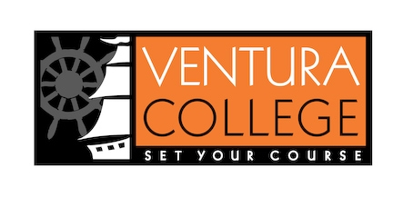

First Year Experience Program
The First Year Experience (FYE) program empowers and motivates first-year Ventura College students to discover a major and career path through a developmental approach, in alignment with California Community College Student Equity & Achievement Program guidelines.
- Student Transition – Provide programming for in-person transition program (FYE New Student Expo) that includes a track for parents in both English & Spanish.
- Counseling and EAC Courses (directed by the Counseling Department) – All FYE Students will take one Counseling or EAC course offered during the Fall semester.
  - COUN V01 – College Success (3 units)
  - COUN V02 – Career Exploration & Life Planning (3 units)
  - COUN V03 – College Orientation (1 unit)
  - EAC V01 – Strategies for Success in College and Life (3 units)
- Follow-Up Programming – All FYE students will attend programs & activities focused on helping them to transition to college life.
- Peer Leaders – Every FYE student will have a Peer Leader that will be trained to support them throughout their first year at VC.
- Early Alert – FYE will work with the Academic Standing Task Force and use Starfish to provide Early Alert interventions for first year students.
- Assessment – FYE will regularly review Service Unit Outcomes to ensure that program goals are being met.
There are currently 894 students in the FYE cohort. We have 750 of our students coming from the 23 sections of the COUN V01, COUN V02, COUN V03, & EAC V01 courses. The rest of our students have taking some form of one of these courses while in high school. We connect with our students via a Canvas shell that we use to communicate information, promote workshops, and collect the assignments required for priority registration.
First-Year Seminar Courses for 2020-2021
In Fall 2018 a group of Counselors worked on the 2019-2020 Counseling Plan for FYE students. This plan included the identification of COUN V01, COUN V02, COUN V03, & EAC V01 as courses required for participation in the FYE program. These courses share common themes that make them appropriate for use as a first-year seminar course in conjunction with the FYE program. Any other courses considered should include the following:
- Career Exploration & Educational Planning; for example:
  - Research and analysis of choice of major and post-secondary pathway to meet career goals
  - Complete career assessment inventory
  - Meet with a Counselor to create a comprehensive educational plan
  - Reviewing transfer guides, major preparation, course to course articulation agreements, and ASSIST
- Study Skills & Personal Growth; for example:
  - Tools and strategies for effective time management
  - Goal setting & decision making
  - Personal values, ethics, and cultural identity
  - Success in the classroom (including goal setting, note taking, & test taking)
- Introduction to Student Services & College Process; for example:
  - Identification and understanding of student support services
  - Understanding college policies: student rights/responsibilities, student code of conduct, student grievance procedure, academic progress, financial aid, etc.
In addition to recommending courses for the FYE program, the Counseling work group also created a document called “Student Success Strategies to Support First Year Experience Students at Ventura College”. This document highlights some teaching best practices that are highly encouraged for use by any faculty teaching a first-year seminar course at Ventura College.
In September 2019, the FYE Team met with the Counseling Co-Chairs and the Dean of Student Services to discuss how to proceed with Counseling & EAC courses for 2020-2021. We discussed the creation of criteria and a process for evaluating other courses to be added. It was decided that a meeting should be held with Administration to confirm that criteria and clarify the process, which could then be communicated to the campus. It was also discussed that human resources should be considered when determining whether to add courses. There is a lot of work that goes into processing and tracking our very large cohort, and we have just two Classified Professionals assigned to the area.
It is the recommendation of the FYE team that any courses considered for the First Year Experience program should include the above course components in their course outline of record and adhere to the “Student Success Strategies to Support First Year Experience Students at Ventura College” document.

Data
Fall 2015 Completion Data (FYE Cohort = 90)
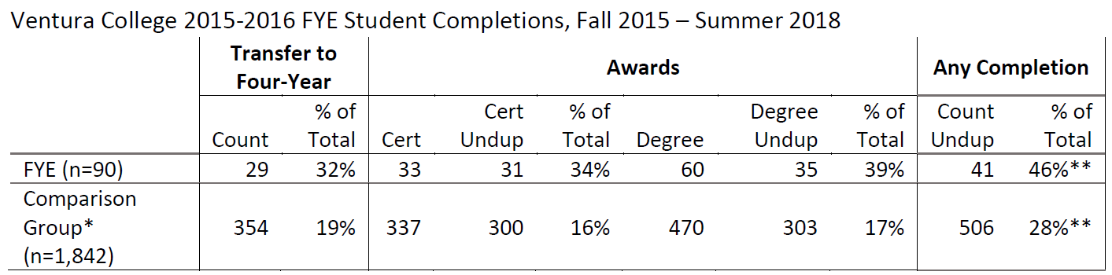
2018-2019 Cohort Data (FYE Cohort = 315) 